**Project**

**Name of company: “Добрый Мастер”**

The main direction of Company activity is Repair of household appliances. We offer our customers high-quality and inexpensive repair of all types of modern equipment for the home with a guarantee on the work performed.

Internet Programming

**NAME:** Akmalkhon Akhrolkhujaev

**ID:** U1610018

Domain: <https://akmaz.000webhostapp.com/>

Github: https://github.com/iuthub/ip-group-project-akmaz.git

**“Добрый Мастер”**

The main direction of Company activity is Repair of household appliances. We offer our customers high-quality and inexpensive repair of all types of modern equipment for the home with a guarantee on the work performed.

The company provides the service of repair and maintenance of refrigeration equipment . The workshop for the repair of household appliances "Добрый Мастер " has been working steadily in the market since 2002; Over the years since the opening, service centers for repairing household appliances have opened in many areas of Tashkent. We got even closer.

The guarantees that Company provide are from 1 year to 2 years. When we take on such long-term obligations, we well understand that their fulfillment requires the impeccable fulfillment of all standards. But, our experience shows that this is possible;

**Company workers:** Qualified specialists. All our masters undergo a thorough selection and pass the required qualification exam before starting work with clients. We do not work with candidates whose experience is less than 3 years.

**Stages of repairing equipment**

* Preliminary diagnosis. It is carried out at the first call of the customer to the service center. By telephone or by photo, which can be attached in a special form of the site, the general nature of the malfunction is established according to the client;
* Diagnostics using special equipment. Defective unit (a specific place of failure) is installed in just a few minutes;
* Directly repair. Replacement of parts, adjustment of operating modes, and so on;
* Test run. Evaluation of the equipment after repair, "delivery" of work to the client.

**Service Prices**

The cost of repairing equipment directly depends on the complexity of the breakdown, the number of parts "for replacement" and the urgency of the order.

The minimum price, which includes the departure of the master and the initial diagnosis is 40,000 sum. If you agree to carry out repairs, these services are free.

Comparing our rates with the prices of other companies operating in Tashkent and Tashkent region, we can see that they differ in a smaller direction. And given the variety of discounts that we provide at all stages of cooperation, they generally become out of competition.

Discounts for customers at all stages of interaction. At the first appeal, we make a 10% discount for everyone. There are discounts depending on the volume of services ordered and discounts on subsequent calls. We constantly think about our customers.

**Repair of refrigerators at home in Tashkent**

Need urgent repair of refrigerators at home in Tashkent? Our company’s specialists are ready to quickly call you and install a faulty component, which will allow you to avoid wasting time and quickly “reanimate” such an indispensable device in everyday life. Other benefits of working with us will be:

Prompt fulfillment of assigned obligations without prejudice to their quality. We are ready to take on the elimination of any malfunctions, regardless of complexity, at home cheaply, while guaranteeing the correct operation of refrigeration equipment.

Repair of refrigerators at home at affordable prices. Our policy in relation to customers is to fix the tariffs for the services provided and to voice the cost of our work after the diagnosis. At the same time, we are always ready for a dialogue with the client in order to minimize his expenses by providing discounts on an individual basis.

Significant experience in the restoration of broken equipment. Each master repairing refrigerators at home has the necessary education and work experience with almost all brands of household appliances on the market.

Still have questions? Contact us right now. We will make cheap repairs of any refrigeration appliances at home, give guarantees and leave only positive memories!

Database: name akmaz | User: root

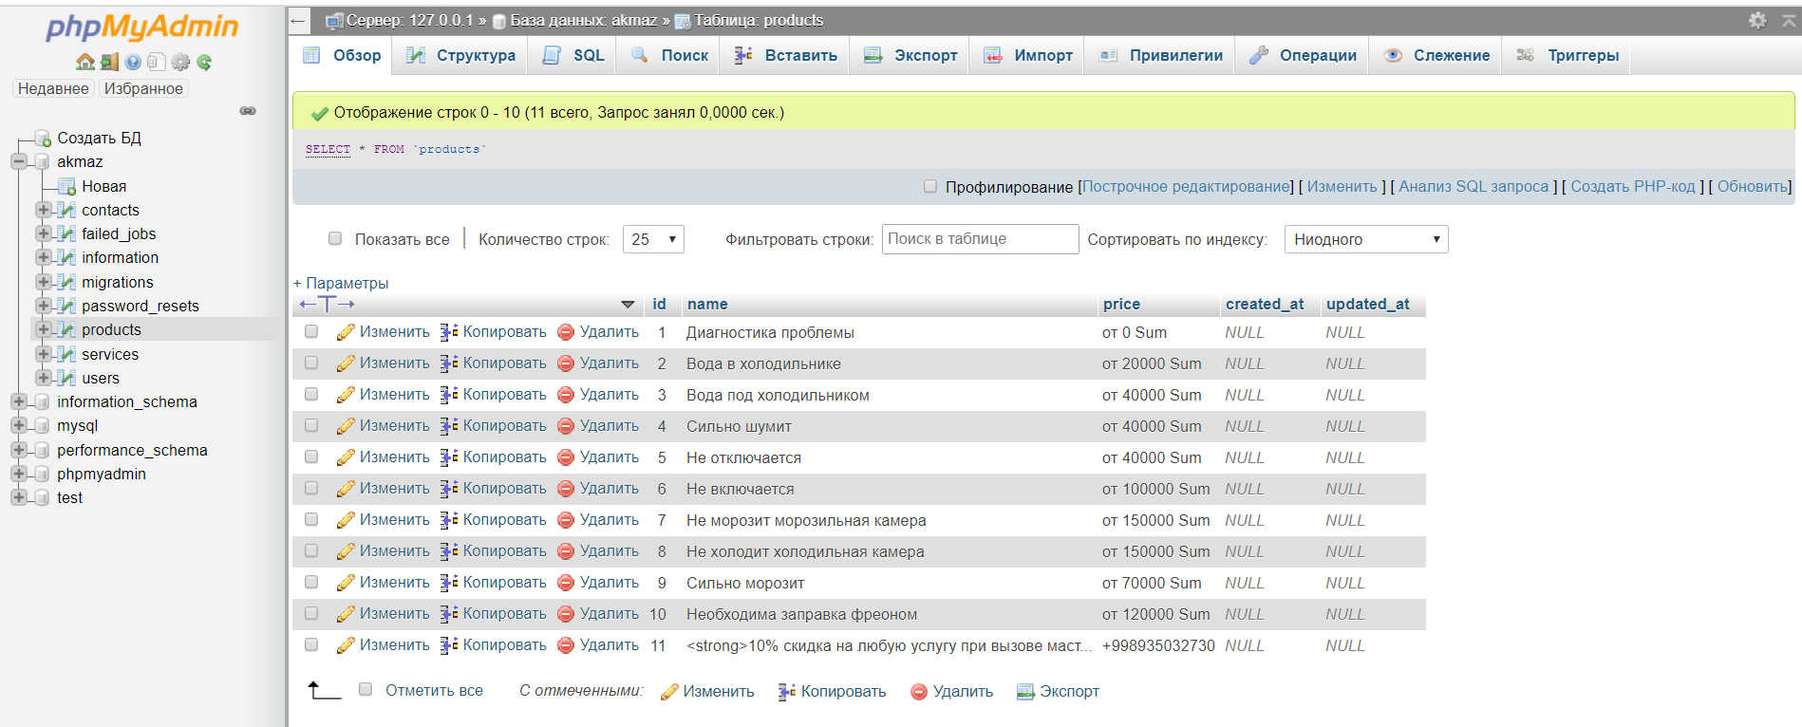

I used free hosting by hostinger

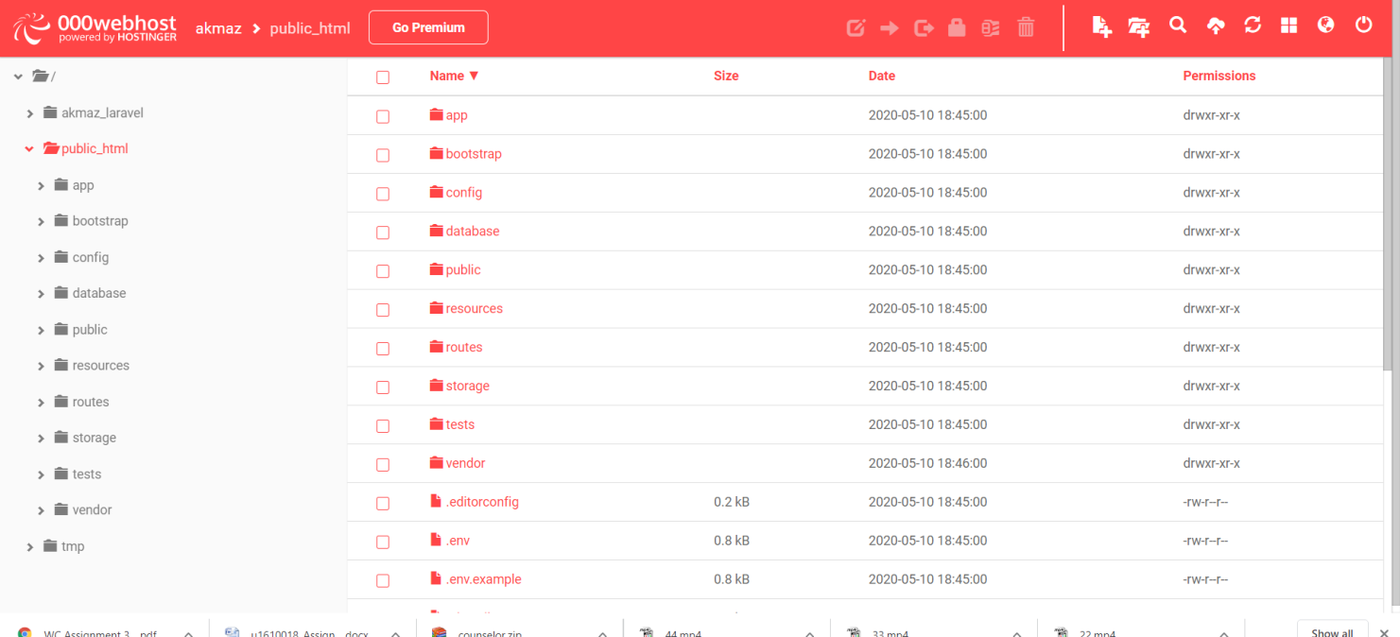

A digital clock displays the time digitally. Instead of using

the rotary mechanism of electromechanical clock, it uses digital

counters to count second, minute and hours. Each sixty seconds

make a minute and each sixty minutes an hour. After twenty

four hours the clock resets and starts from initial condition. In

stopwatch, separate switches are provided to start and clear it.

It can count up to 60 minutes

A digital clock displays the time digitally. Instead of using

the rotary mechanism of electromechanical clock, it uses digital

counters to count second, minute and hours. Each sixty seconds

make a minute and each sixty minutes an hour. After twenty

four hours the clock resets and starts from initial condition. In

stopwatch, separate switches are provided to start and clear it.

It can count up to 60 minutes